1. Design DFA using simulator to accept strings in which a’s always appear tripled over input {a,b}.

OUTPUT:

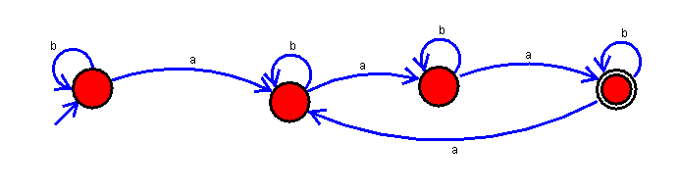

RESULT: The DFA using simulator is accepting strings in which a’s always appear tripled over input {a,b}.